Woodford Times

Woodford Historical Society
Founded 1932

Newsletter Spring 2026

ALL ITEMS IN THE SOCIETY’S NEWSLETTERS ARE COPYRIGHT WOODFORD HISTORICAL SOCIETY/THE AUTHOR/THE PHOTOGRAPHER AND MAY NOT BE REPRODUCED WITHOUT WRITTEN CONSENT.

Editorial

A warm welcome to 2026.

Hopefully the bad weather is behind us now and we can look forward to Spring.
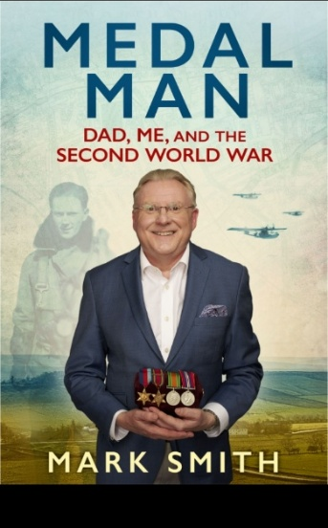
The Committee continues to work behind the scenes. Judith is already booking talks for the 2026/27 season, for our popular speakers we need to get in early. Sadly Mark Smith (Antiques Roadshow fame) will no longer be able to attend our meetings as a Speaker as he has moved to Somerset. His talk in April will not go ahead, it has been replaced by one from Lyn Haseldine Jones on Old Postcards of Woodford. You may be interested in Mark Smith`s book that is being published at the end of January by Penguin.

In the Newsletter, members will be able to see how the public has used our Website and the variety of enquiries we receive and answer.

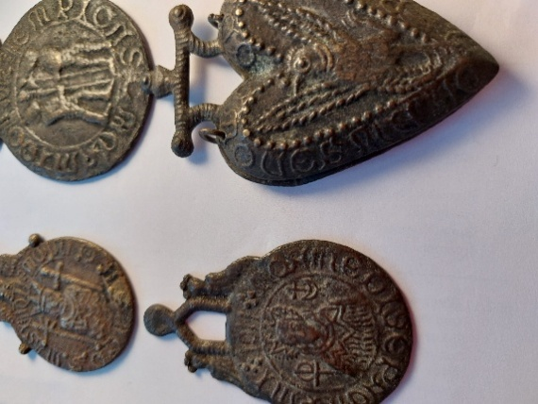
You may recall that during the sorting the of the Archives we came across some Pilgrims Badges. Alison McBrayne, one of our Committee members visited the London Museum Docklands, where they have similar items on display, to get more information. It was likely that they are fakes produced by a couple of enterprising nineteenth-century Thames mudlarks, William Smith and Charles Eaton, known as Billy and Charley. They sold them as genuine badges that had been found along the Thames shoreline. We have been in contact with the Museum of London who have their own collection and are checking to see if they have anything similar. At present the Museum is moving its acquisitions to a new Museum, so it will be a while before we get a definitive answer as to their provenance.
Enclosed with this Newsletter are details of the AGM on 12th March 2026

Minutes of the 2025 AGM
Agenda for the 2026 AGM
Accounts and Financial Report will be available at the AGM

Peter Lawrence, our President will present a talk on `The Rise and Fall of Wanstead House`

We will again be serving tea/coffee from 2pm before the AGM starts at 2.30pm.

A reminder below for forthcoming talks for the remainder of the season are as follows:

12th March: AGM and The Rise and Fall of Wanstead House
Speaker: Peter Lawrence
9th April: Old Postcards of Woodford
Speaker: Lyn Haseldine Jones
14th May A Place for Us – The Story of the Whites Home
Speaker: Keith White

As I have said Judith is busy booking speakers. We have booked the hall at All Saints Church for our 26/27 season and the dates for your diaries are as follows (subject matter for the talks to be confirmed).

2026
10th September, 8th October, 12th November, 10th December

2027
14th January, 11th February, 11th March, 8th April, 13th May

I always ask that if there is anyone who would like to join the Committee they will be warmly welcomed. You do not have to be an Historian and the work is not onerous. The Committee meets about 4 times a year and the meetings generally last no more than 2 hours.

I look forward to seeing you all.

Sue Ralph

WEB SITE ENQUIRIES FOR 2025

We had a total of 45 enquiries from the public on the Society`s Website for year to December 2025. They are as follows:

Information required on local buildings, sites, roads, Epping Forest, Glebelands and the Ice House in Monkhams
Total: 21

Information on the Society`s membership and programme details
Total: 7
Offers of artifacts to Archives:
Total: 9

Individuals wanting the Society to research into their family history
Total: 1

Offers of articles to the Newsletter
Total: 3

Miscellaneous
Total:4

We only answer, where we can, enquiries regarding local history or direct the enquirer to where they can find the information. We do not undertake any family history research

POSTCARD FROM THE PRESIDENT – SPRING 2026
Hello Everyone,
I hope you have kept well and warm during the past winter and are looking forward to getting out and about now that spring is here. For Linda and I, it’s been a rather strange winter, as just before Christmas, Linda got a call from our local hospital to come in for a long overdue knee replacement operation. That meant seasonal family get togethers were put back as I’m sure some of you will know, a knee op. is more complicated than other joint replacements and takes much longer to heal and get mobility back. Also, because of the drugs, Linda was in no way ready for a typical roast Christmas meal. Apparently, her lack of appetite was due to taking morphine, so I was thinking of taking some of her medicine as it appeared to be a great dietary assistant !!!
Being “confined to barracks” and having seen a special offer advertised, I decided to take out a year’s subscription with one of the well-known family tree sites. Well, “opening the floodgates” comes to mind. Within a couple of weeks and connections with other family tree administrators on my mother’s side, apart from confirming our immediate Walthamstow family connections, her Fenland roots have also been verified, and I’m now back to the 18th century. However, all this information will need double checking as there are many variations in spelling and dates. It also brings to mind, a few years ago, whilst giving a talk to a U3A at March, near Chatteris, my mother’s family ancestral town, I just mentioned her family connection with the area, I was immediately introduced to cousins, perhaps umpteen times removed, who were members of that U3A !!!
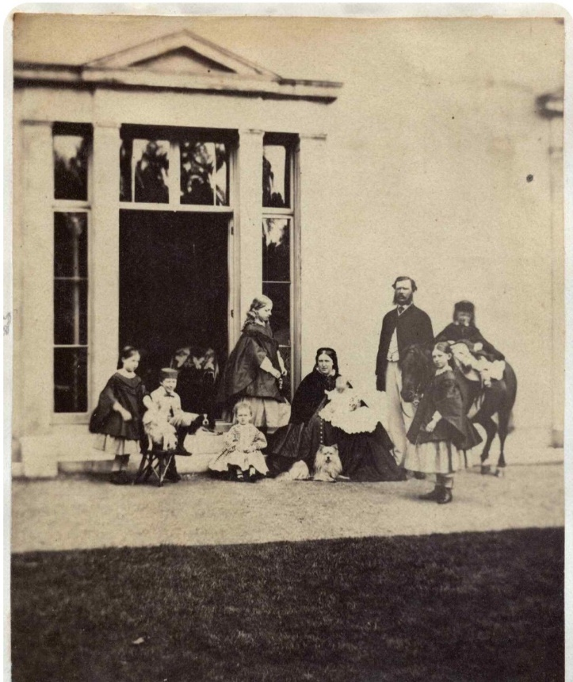
Connections with my local Mr. Barclay continue to bear fruit concerning Henry Ford Barclay of Monkhams. As I continue to help him identify locations in Walthamstow, Leyton and Woodford, here is his latest contribution, taken in 1862. It shows Henry Ford Barclay, City banker, on the right, with his wife and family in the garden of Shrublands, his house in Shernhall Street, Walthamstow. Two years after this photograph was taken, he and his family had moved to Monkhams where he remained until his death in 1892.
Before the estate began to be divided up for development in 1903, Monkhams had a variety of notable owners and occupiers. One example is Arnold Hills of the Thames Ironworks at Leamouth, Canning Town. He bought Monkhams in 1892 and set about having elaborate sunken gardens and fountains constructed near the house. The fountains had underwater electric lighting, that were connected and maintained via tunnels. Sections of the sunken gardens and tunnels remain in on the estate today. Several estate workers’ cottages were built in Monkhams Lane that survive today. Arnold Hills is remembered with fondness in the Canning Town and West Ham area as he introduced the eight-hour day, profit sharing, sport and socializing for his Ironworks work force. He is especially remembered for the Thames Ironworks F.C. football team that many will know became West Ham United F.C. So, whilst watching “Match of the Day” on the BBC and West Ham is featured, when you hear the chants, “Up the Hammers” or “Come on You Irons”, they both refer back to the Ironworks and Arnold Hills of Monkhams, whose family remained major shareholders of the club until about 25 years ago.
Well, with West Ham United not doing so well this season, I’d better close before I jinx them anymore, so I’ll close this postcard by wishing you good health and an enjoyable spring and summer.
Best wishes,
Peter

Over 30 years ago Sheila Luker, a former member, wrote an article about the history of George Lane. So much has changed! We have reproduced part one of the article with a little editing and two present day photos.
Felicity
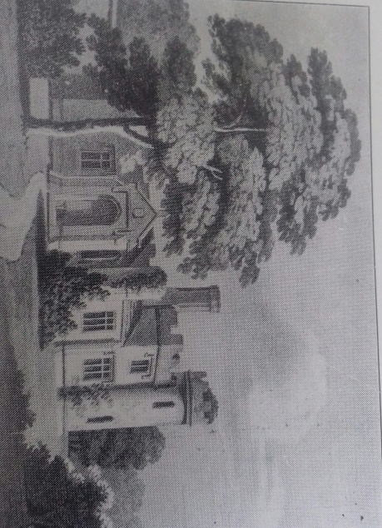
A Brief History of George Lane (Part 1) Sheila Luker

Before the Eastern Counties came in 1856, George Lane was a well established rural thoroughfare, connecting the lower (Chigwell) Road and the upper (High) Road with the George Inn at its junction with the upper road. It served two estates, the Rookery on the north east side, the mansion on what is now a car park and office block and Frithman’s on the south west (London) side. The house was situated at the rear of where the International Store is today.
On completion of the railway, which cut through these estates, there appeared a two storey station building, gated level crossing and signalman’s accommodation (Gate Cottage) at George Lane and from then on its rural aspect gradually declined as it evolved into the commercial and residential area that it is today. By 1861 it had become the Great Eastern Railway. The Railway Bell was built shortly afterwards in the 1860s but was not allowed to start trading until about 1880.
The shops of greatest age in George Lane were built and in use at around this time (1878) between the Railway Bell and Cowslip Road on what had been the kitchen gardens of the Rookery Estate. Building continued in this area and the premises were given names like Orchard House, Orchard Terrace and Orchard Villas as a reminder of what had been before. They all survive today.
Opposite these, between Pulteney Road and the station are a row of shops which were called the market at the beginning of the 20th Century. Most were built about 1899 although the earliest was there by 1885
Over the line, the block of shops between Posners and Radio Rentals, then called 1 – 6 The Pavement, were in use by 1886, with a timber merchants behind them built a little earlier in 1882.

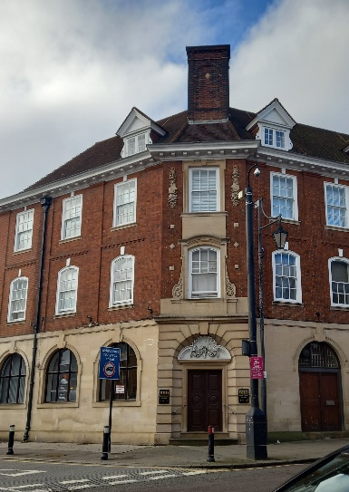
Opposite these and extending just beyond Marlborough Road junction, a sweep of mainly four storey premises were erected between 1884 and 1893, except for 116 – Freeman, Hardy and Willis which opened in 1899.

The area between Marlborough Road and Cleveland Road was previously the site of a Victorian house. This was demolished in about 1903 for the building of what was the National Westminster Bank (1905) and the row of shops extending to Cleveland Road, then called 1 – 8 Cleveland Parade (1904). Similar four storey premises were built opposite about a year later and were then 9 – 14 Cleveland Parade. From the optician’s (Aves) to the former Post Office was built about 1932 on what had been the Rookery’s front garden. The mansion was demolished in 1830.
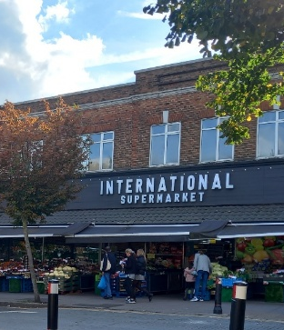
The building of Barclays Bank (now closed) began in about 1927 on the site of what had been an old house called The Cottage, this had been in existence since before 1863 and was demolished in 1926. The shops from Barclays to what is now Boots, but not including it, were trading between 1931 and 1935. Woolworths (now International Supermarket) came a little later in 1938/9. The old house Frithman’s was demolished in 1931 to make way for these.
The Plaza Cinema which was previously on the Boots site was built by 1913. The Congregational Church which stood beside it opened its door at the end of the 19th Century and was demolished in 1983 to make way for Sainsbury’s.
Over the road, premises between the Shrubberies and Southdene Surgery were occupied between 1899 and 1903 and Electric Parade at the top of the lane was built by 1925.
Between the Congregational Church and the George Inn were various business concerns including a livery stable, a builders’ yard and the premises which used to house English’s the Undertakers were built in 1883.
The subway of the station was under construction at the outbreak of the Second World War and was severely damaged by a bomb in 1940. The viaduct was constructed in 1947/8 in conjunction with the electrification of the railway.
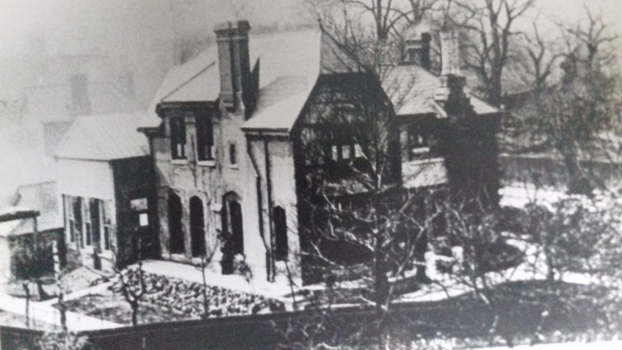
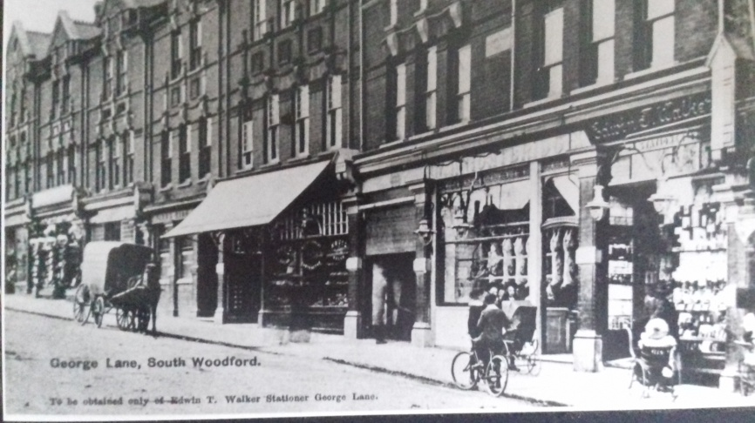
1.1904 Postcard – A row of shops (107 – 117) built between 1886/89 except for 115 – Devon House, Freeman, Hardy and Willis which appeared 10 years later. Before numbering began during the First World War, shop buildings and houses had names. 111 was Parr’s Bank. It had been called Luton House and was previously in use as a milliners and dressmakers when it first opened about 1889. The bank opened in 1893 and the Bank Manager lived in the accommodation above. In around 1906 the bank moved to premises on the other side of the road (110). The stationers (who published this postcard) and a butchers shop were bombed in 1940 and later demolished.
2.This Victorian House was built around 1878 between Cleveland and Marlborough Roads. It looked onto George Lane. At one time it was called Bellerive by its second owner William Powell Griffiths, who lived there from about 1893 – 1902. It was demolished in 1903. William Griffiths apparently decorated his house with fairy lights during local celebrations to mark the ending of the Boer War. In 1904 the site was cleared so that building could start on what used to be the National Westminster Bank and other shops.
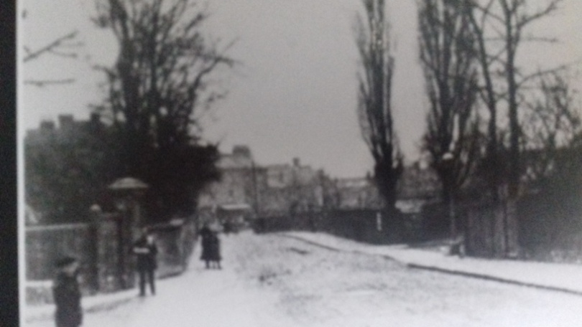
3.This picture shows the site between Marlborough and Cleveland Roads where the house Bellerive used to stand. It was demolished and the site cleared by the time of this photograph was taken in early 1904. Cleveland Road can be seen behind the lamp-post on the right. The gates on the left were the entrance to the old house called the Rookery.

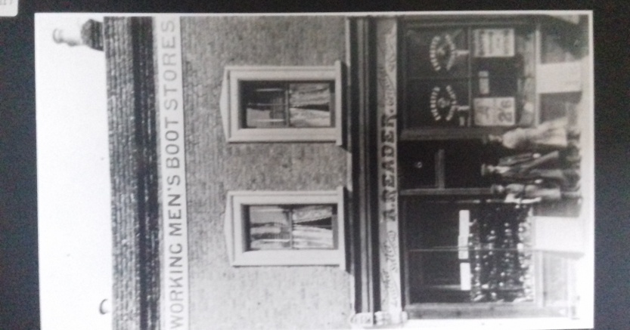
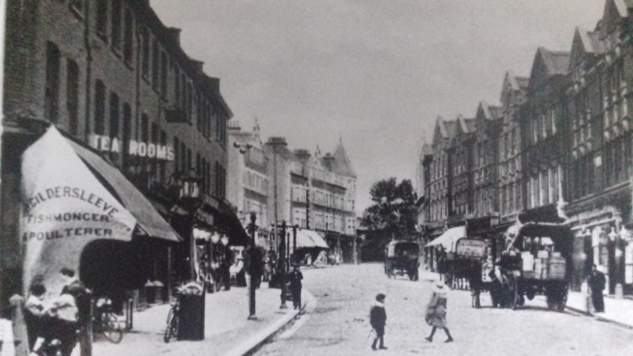
4.The photograph was taken (c1905) from just above Railway Approach, looking approximately west up George Lane to the Cleveland Road junction. The group of shops to the left were called the Pavement and goods were displayed outside on the much wider frontage. . The pawnbrokers is the last shop. A greengrocer’s called Muggleton’s and a corn merchants called Gibson’s were also on this terrace. The Cottage is behind the tree at the junction with Cleveland Road. Horse drawn vehicles and bicycles can be seen.
5.Built about 1884 this shop (65) is on lower George Lane opposite Pulteney Road or in those days 8 Orchard Terrace. Albert Reader started business here in 1906, about the time of the photograph, and continued until his death in 1932. The Woodford Times newspaper reported that he was a highly esteemed member of the community. His wife carried on for a few years before retiring. It later became a launderette.

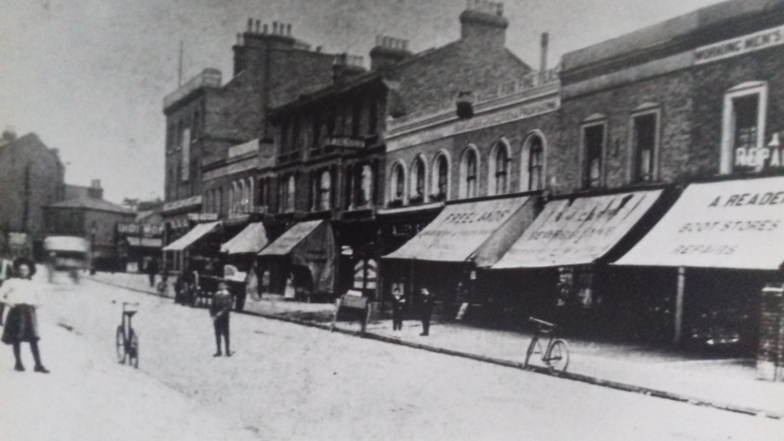
6.Taken (c1907/08) from the lower corner of Pulteney Road, across and up lower George Lane from Readers (65) towards the Railway Bell and railway line. All this area was built on the Rookery kitchen gardens and these shops were called Orchard House and orchard Terrace. Freelands was a high class grocer’s, in business from 1903 till after the Second World War. Leonard Kinns was a florist. He had a nursery in Glebelands Road.
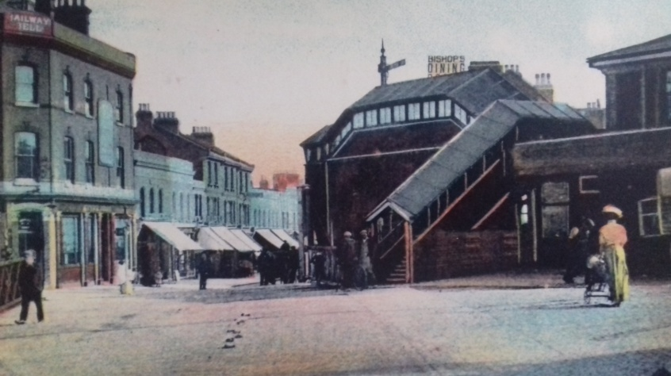
7.George Lane Station booking hall premises were two storeys high and provided living accommodation for the Stationmaster. It was later reduced to one storey. The Great Eastern Railway horse drawn van was outside the building and there was a covered railway bridge. Picture c1909/10
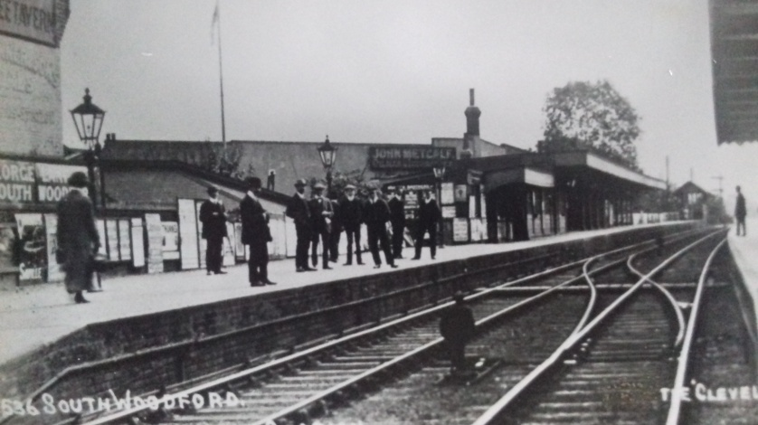
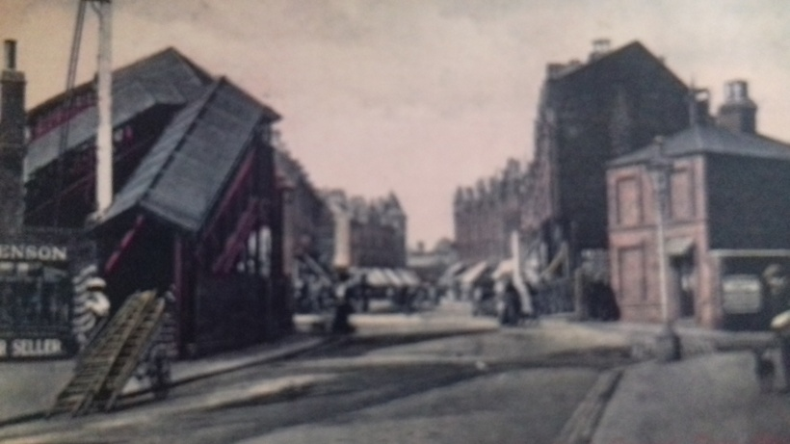
8.Taken from the pavement outside the Railway Bell (c 1910/11) looking over the railway level crossing. No. 2 the Pavement across the line has a little bell sign on the wall, displayed by the National Telephone CO. (public call office). There is an advertisement hoarding and the pawnbrokers sign behind, above Gibson’s the corn merchant. The Cottage is no longer quite so hidden by greenery. Warnes the outfitters moved into the turreted building in 1914. All the shops on the other side, Frederick Hedges the drapers 105 since 1893 and Matthews the chemist at 97 since 1899. The latter moved to 133 after bomb damage in 1940. The boot repairer’s shop, by the station, in lower George Lane was also a boot and harness maker when it started c1895.

WOODFORD HISTORICAL SOCIETY
ANNUAL GENERAL MEETING
You are invited to the AGM to be held on Thursday12th March 2026 at 2.30pm at All Saints Church, Woodford Wells
AGENDA
- Apologies for Absence
- Minutes of the Annual General Meeting held on Thursday 13th March 2025
- Matters Arising
- Chairman’s Annual Report presented by Sue Ralph
- Annual Financial report presented by Jean Wyber and adoption of Annual Accounts 2025
- The Constitution
- Appointments of President and Vice Presidents President – Peter Lawrence Vice-Presidents – Janet Lovell John Lovell Jill Hicks
- Election of Officers and Committee Nominated Officers and Members are Chairman – Sue Ralph Treasurer/Membership Secretary - Jean Wyber Secretary – Felicity Banks Committee Members –
Dick Walker
Sharon Barnett (currently arranging refreshments and member contact)
Judith Roberts (currently booking speakers for next year)
[Steve Fothergill (currently arranging
[Mike Knell technology at meetings)
Alison McBrayne
Officers named are willing to stand again

- Confirmation of Honorary Members.
Peter Lawrence, Janet Lovell, John Lovell, Georgina Green, Jill Hicks and Sue Ralph
- Appointment of Financial Examiner for 2026
- Any Other Business and closure of Annual General Meeting

-oOo -

The Annual General Meeting is to be followed by a talk given by our President Peter Lawrence titled The Rise and Fall of Wanstead House

WOODFORD HISTORICAL SOCIETY
ANNUAL GENERAL MEETING MINUTES
HELD ON Thursday 13th March 2025
at 2.30pm at All Saints Church Hall, Woodford Wells.

Item
1. |  | The Chairman Sue Ralph welcomed everyone to the Annual General Meeting  Apologies – had been received from Dorothy Lockwood, Janet and John Lovell, Georgina Green, Ursula Myers, Dorothy Sullivan, Brian Challis, Helen Gilman and Jill Hicks
2. |  | Minutes – from the AGM held on Thursday 14th March 2024 had been circulated. Acceptance of the Minutes: Proposed – Mike Knell: Seconded – Steve Fothergill. These were agreed.
3. |  | Matters Arising – None
4. |  | Chairman’s Annual Report:  I would like to welcome you all to our AGM. A special welcome to Peter Lawrence, our President who has come from Norfolk.  As you are aware I am always asking for help, and Alison McBrayne, volunteered and was co-opted to join the Committee. Thank you, Alison. Again, if there is anyone else who would like to step forward, please do so.  The Society has undertaken a lot this year within the Woodford Community – Woodford includes Woodford Green, Woodford Bridge, Woodford Wells and South Woodford.  It has been a memorable time for several organisations who have celebrated their existence within Woodford.  We were involved with Churchfields School who celebrated 150 years. The school received from us a Chess set that we found in the Archives. It is on long term loan and is now used in their annual chess tournament. We also had a stand at their celebratory day on 8th June. We were able to assist All Saints Church who celebrated their 150 years. Other memorable celebrations were Mill Grove 125 years and Woodford Rugby Club 100 years.  The Museum opened in Redbridge and again as a Society we were able to contribute to the preparation. If you have not visited, please do as the staff have done a magnificent job. Our Archives held at the Heritage Centre have been listed and the cataloguing is underway.  The Website is being used a lot more, we have become more efficient in answering the enquiries that we receive. We are on Facebook, but wonder if there is any member who would like to take on Instagram and Twitter, please step forward.  We are as a Committee, already thinking about the Society and its 100 years which will be in 2032. It seems some way off, but time flies by so quickly. If anyone has ideas for what would be a fitting memory to 100 years of the Society, please let us know.  I would like to thank my fellow Committee members, Felicity Banks our Secretary who produces the Newsletter and undertakes any admin, Jean Wyber, our Treasurer who balances the books, Judith Roberts who arranges the talks and has already arranged the 2025/2026season, Sharon Barnett who sends out all the e-mails, Steve Fothergill who looks after the technical side and Dick Walker, Mike Knell, Alison McBrayne and Rowena Rudkin who have supported us all. Please show your appreciation.  I did report that I was going to stand down at the end of the 24/25 season. I have agreed to continue until the end of the 25/26 season and hope that by that time a new Chair will be appointed.  I must also thank all of you who continue to support the Society and finally the staff of All Saints Church.  Sue Ralph
5. |  | Annual Financial Report: Jean Wyber  The Treasurer presented her report. She recommended that the annual subscription fees for 2025/6 be £15.00 for a member or £25.00 for a couple living at the same address.  The report and accounts were circulated and are attached in the WHS file.  Thanks were extended to Fred Shearer for stepping in as Financial Examiner for the 2025 Accounts.  Peter Lawrence proposed the adoption of the Accounts; Seconded by Judith Roberts. Agreed by Members  The Treasurer was thanked for the work done as Treasurer.
6. | The Constitution  No motions had been received
7. | Appointment of President and Vice Presidents  The President – Peter Lawrence  Vice Presidents – Dorothy Lockwood, Janet and John Lovell, Jill Hicks  Proposed by Dick Walker and Seconded by Judith Roberts. Agreed by members
8. | Election of Officers and Committee  Peter Lawrence took the Chair.  Chair – Sue Ralph  Secretary – Felicity Banks  Treasurer/Membership Secretary – Jean Wyber  Committee Members – Dick Walker, Sharon Barnett, Judith Roberts, Steve Fothergill, Mike Knell and Alison McBrayne  Election of all Officers and Committee nominated were proposed by Mick Roberts and seconded by Rowena Rudkin. This was agreed by members.
9. | Confirmation of Honorary Members  Peter Lawrence, Janet and John Lovell, Georgina Green, Jill Hicks and Sue Ralph were confirmed as Honorary Members.  Proposed – Sharon Barnett: Seconded Rowena Rudkin. Agreed by members
10. | Appointment of Financial Examiner  The nomination of Fred Shearer was Proposed – Jean Wyber: Seconded – Mick Roberts. Agreed by members
11. | A.O.B. –Chair closed the AGM and thanked everyone for attending.

Following the AGM -
The President - Peter Lawrence gave a talk “Delving into the Archives Part 2”

